ANNEXE 1: List of office equipment
Materials and equipments | Technical details | Total N.of Items | Pictures
Metal cabinet 2 doors | two doors with adjustable shelf stoper, lockable, | 4 | 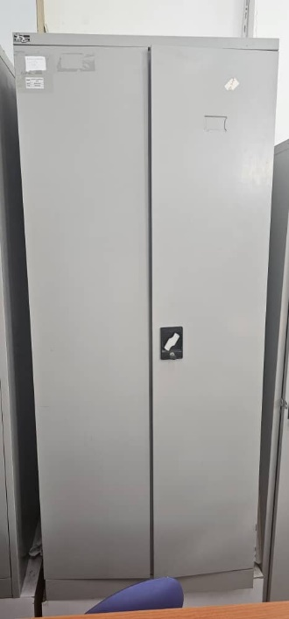
Office | 1m20 semi-metallic desk  Shape: rectangle  With side storage drawer | 4 | 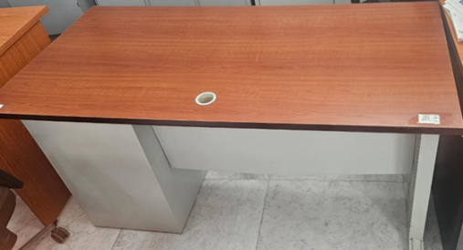
Visitors chairs | High quality meshed back rest, chromed frame structure, openair back backrest, chromed made sledged base together connected with arm rest | 8 | 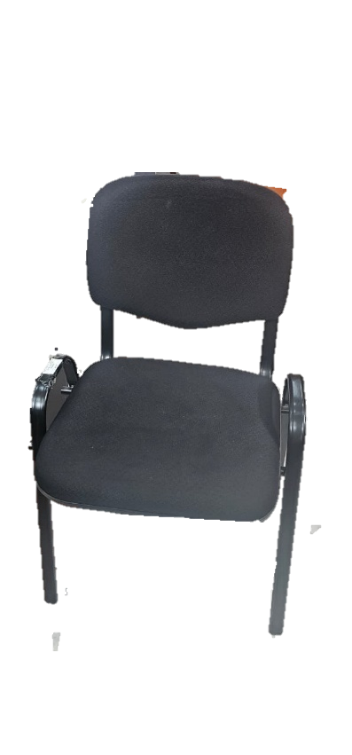
Office chair | mesh managerial swivel high back chair with armrest, Air-conditioned net at the back rest, hydraulic gas lift system & tilting back, strong chromed star leg with five caster | 4 | 